Installation Guide

JWebSocket
JMXPlugIn
1.0

1. Download Application Process
In order to install JMXPlugIn module you should proceed to download the jWebSocket Server package, in which shall be included JMXPlugIn module.
The following table shows the URL where you can find the jWebSocket Server installation manual. This address is also the link for downloading the jWebSocket Server package.
Package | Size | Link
jWebSocket Server | 12.4 MB | http://enapso.com/?q=node/156
2. Characteristics of the installation environment
For a correct operation of JMXPlugIn must be taken into account the following aspects:
- OpenJDK 1.7 or higher installed.
- Ports 8080, 1099 open and unused.
3. Installation Environment
- Download jWebSocket Server package from the address noted above.
- Unzip the downloaded package to a selected directory.
- Create the JWEBSOCKET_HOME environment variable and assign it as value the path to the directory "jWebSocket-1.0" where was unzip the jWebSocket Server package.
3.1 Hardware (Optional)
JMXPlugIn module does not require the use of additional hardware for its operation.
4. Settings
  - Default User Settings
JMXPlugIn has a configuration file for authentication. The user “admin” with the password “jmxadmin” is defined by default. It provides access to the plugin without having to make any changes to the settings.
  - Modify Default User
To modify the configuration file for authentication, you must access to the folder that contains the jWebSocket server settings. Next you should edit the “jmxPluginConfig.xml” file located at the “JMXPlugIn” folder. This file contains the following default settings:
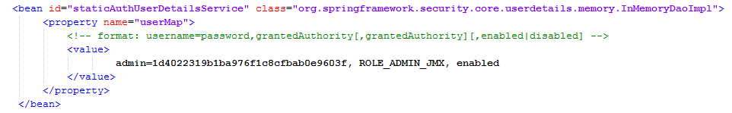
Note: for more information about the server folder structure you could access to the Folder Structure section.

To change the user "admin" you should take into account the following aspects:
- The password must be encrypted with MD5.
- The credential required for access to the module is "ROLE_ADMIN_JMX".
- The user must be enabled for authentication work properly.
  - Add a New User
To add a new user to the authentication module you must access to the settings mentioned above and add a new line with the desired values.
Example: To add a user “administrator" with the "ROLE_ADMIN_JMX" credentials. The configuration file must look like follows:
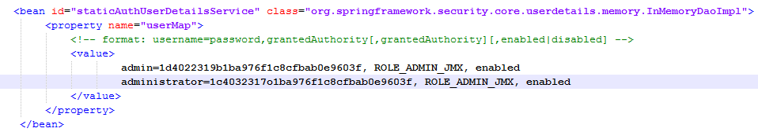
To add a new user you should take into account the following aspects:
- The password must be encrypted with MD5.
- The credential required for access to the module is "ROLE_ADMIN_JMX".
- The user must be enabled for authentication work properly.
- How can function?
The steps for switching on the JMXPlugIn are the same of running the jWebSocket Server, these are:
- Run the MongoDB database server.
- Run the web server that publishes all the web clients.
- Run the jWebSocket server using the command line:
java -jar $JWEBSOCKET_HOME/libs/jWebSocketServer-Bundle-1.0.jar
6. Technical Support
In case of any problems during the installation process of JMXPlugIn, please contact with: Lisdey Pérez Hernández, E-mail: lisdey89@gmail.com.

